**CAR SALES TRACKING AND REPORTING SYSTEM**

**Problem Description**

In the automobiles industry, dealerships often deal with a large number of transactions on a daily basis. These transactions include various details such as car models sold, customer information, dates of purchase, prices, and salesperson details. Many small to mid-sized dealerships still rely on manual entry methods or spreadsheets, which are prone to human errors, lack data security, and make it difficult to analyze performance over time.

Manual methods of tracking sales and management of huge data in the car companies often lead to errors, inefficiencies, and data mismanagement. CarLogix : Smart sales monitoring system solves those problems by storing data in a structured file and providing functionality to add, view, and analyse sales.

*Real-Life Applications of the system are:*

1. Car Dealerships:

Dealerships use this kind of system to track daily, monthly, and yearly car sales. It helps us to recognise the best seller models of the cars, manage stock levels, and adjust prices of the cars.

2. Automobile Manufacturers:

Car manufacturers utilise this system to read the details about customer preferences, enabling companies to design models based on public demand. Customer's satisfaction can be a boon to the companies.

3. Government Bodies :

Government agencies also keep the overview of the car sales data to track the market, implement the various taxes and regulations, and introduce policies promoting sustainable transportation.

4. Fleet Management Companies:

Business companies which manage huge vehicles use it to track purchases and resale trends. It helps further in financial planning and asset management of their company.

**FLOW DIAGRAM:**

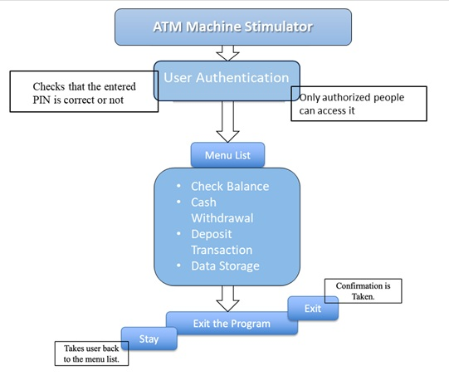

1. Add sales
2. View sales
3. Find total sales
4. Find total sales by brand
5. Find total by model
6. Find total sales by color
7. Maximum minimum sale record
8. Exit
9. Find total by month
10. Find total by year

CAR SALES TRACKING, REPORTING SYSTEM

If(choice!=8)

Exits the program

no

yes

Takes user back to menu list

**Different modules used in the system are:**

* + 1. **User authentication module**

**int login():**

The function provides authorized access for the users. It ensures security and safety of the user system.

* + 1. **Input module and File handling module**

**void addsales()**  
The function allows the user to enter a new car sale record.  
Prompts the user for:

Brand, model, colour, quantity sold, year and it also saves the entries entered by the user to the file.

void savesales();

and it saves the entries entered by the user to the file.

* + 1. **Display Module**

**void showsales();**

This function displays the sales records on the terminal and makes it easy to view for the user. Enhanced display creates a better understanding of the program.

* + 1. **Maxmimum minimum module**

**void maxsale();**

This function assists the user to find the maximum sale of car, the best-selling cars, the top leaders of the market. It will display the maximum sale and its details on the terminal.

**void minsale();**

This function assists the user to find the minimum sale of car, the lowest-selling cars. It will display the minimum sale and its details on the terminal.

* + 1. **Sum Module**

**void totalsales();**

This function calculates the total sales, the total number of cars sold by the company. It displays the total number on the terminal.

**void totalbychoice(const char[]);**

This function calculates the total number of cars sold based on a specific field like model, color, brand, month, year, based on user’s choice. User inputs his choice and the function is being called for that particular case.

For example if the field is “brand”, then inside the function it prompts the user to input which brand and then calculates total cars sold of that particular brand.

* + 1. **String functions module**

**int strcompare(const char *a, const char *b)**

The function performs a case- insensitive comparison on two strings. The function is highly beneficial which helps us to compare the user’s choice with the specific field for which the total needs to be calculated.

**char tolowerc(char ch)**

The function converts every uppercase character to lowercase. It is used by the strcompare function.

**PLATFORM USED :**

Visual studio code

**SCREENSHOTS OF PROJECT OUTPUT :**

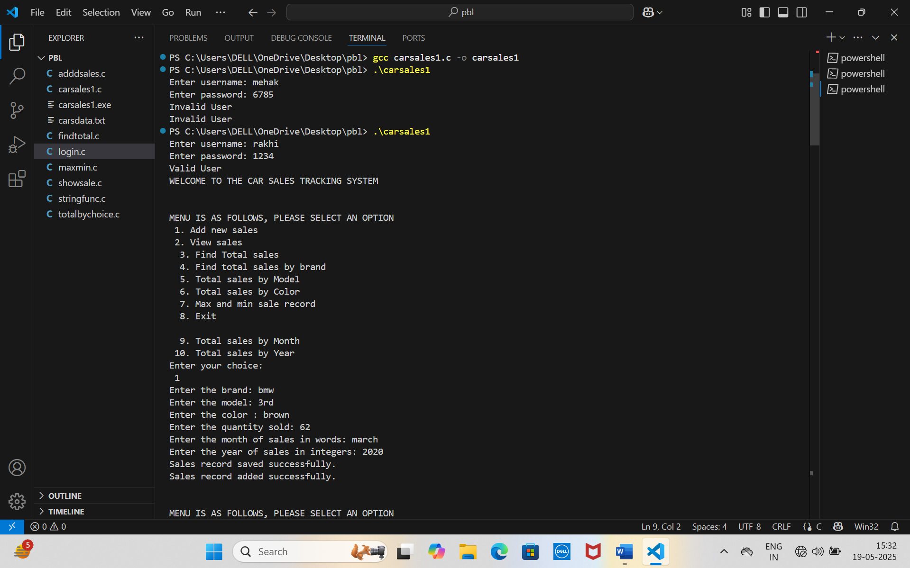

On entering choice 1

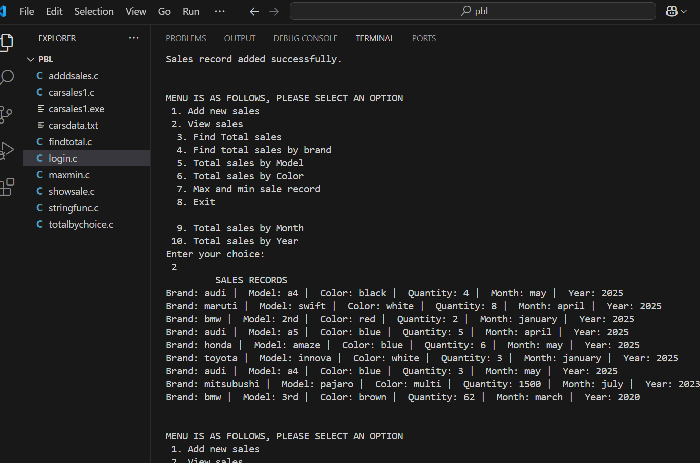On entering choice 2

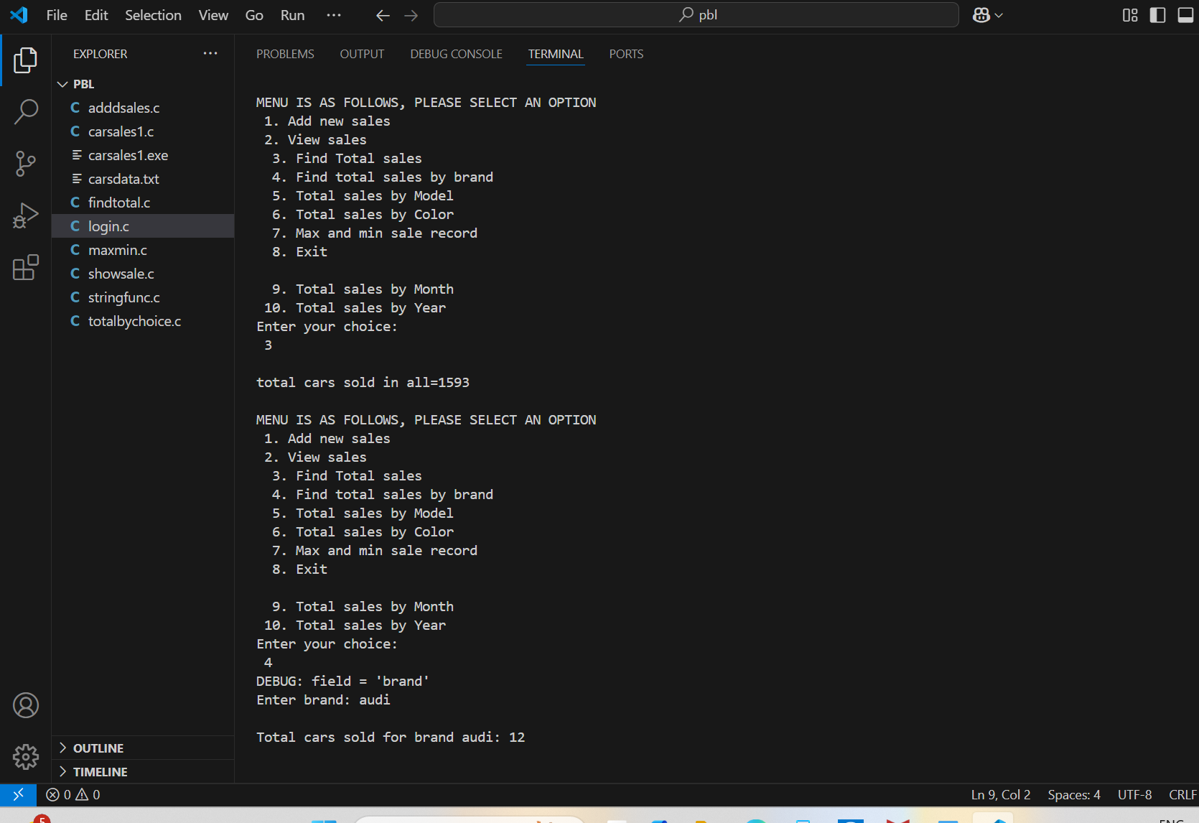

On entering choice 3 and 4

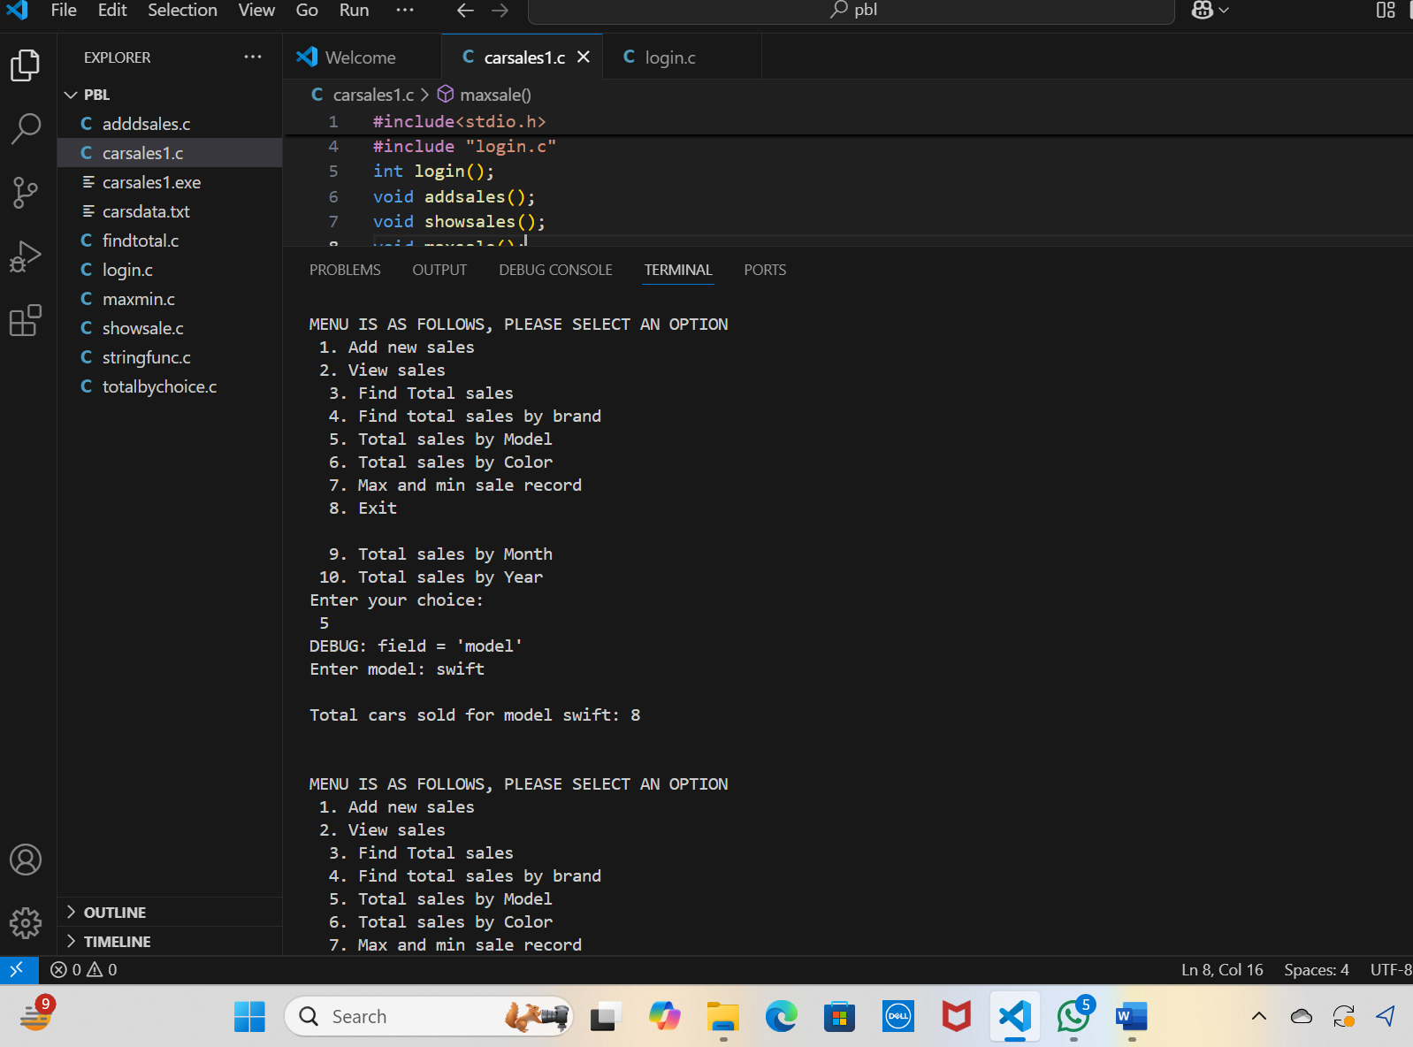Output on entering choice 5

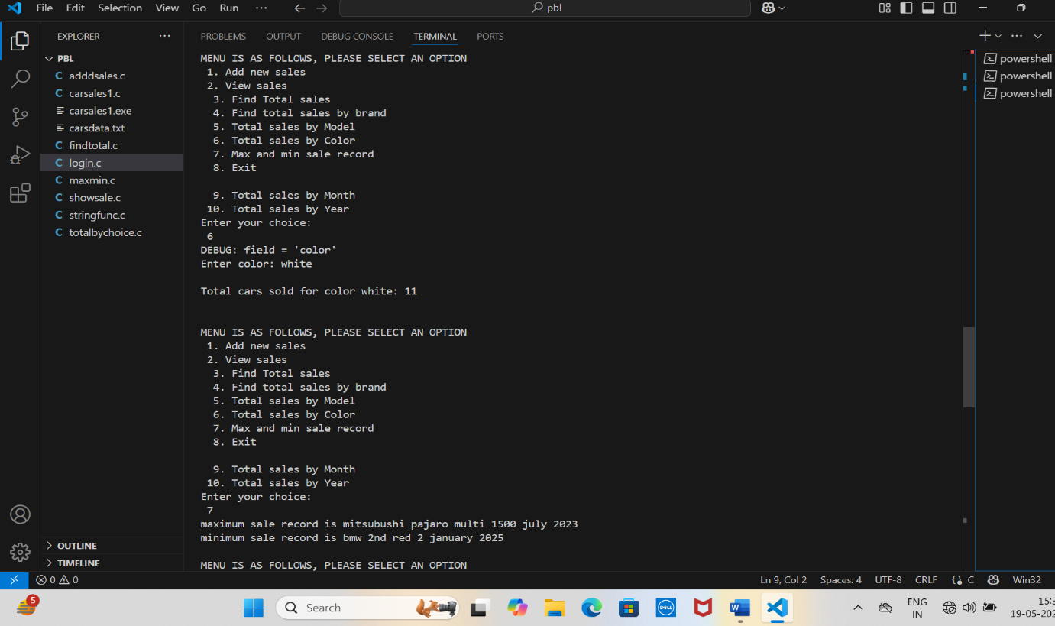

Output on entering choice 6 and 7

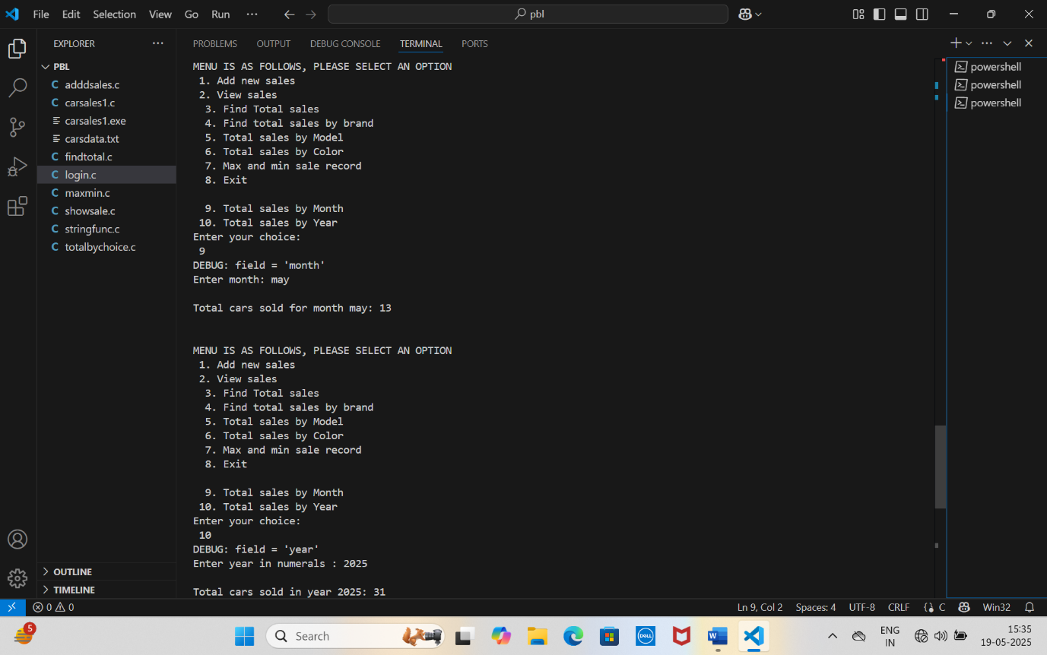

Output on entering choice 9 and 10

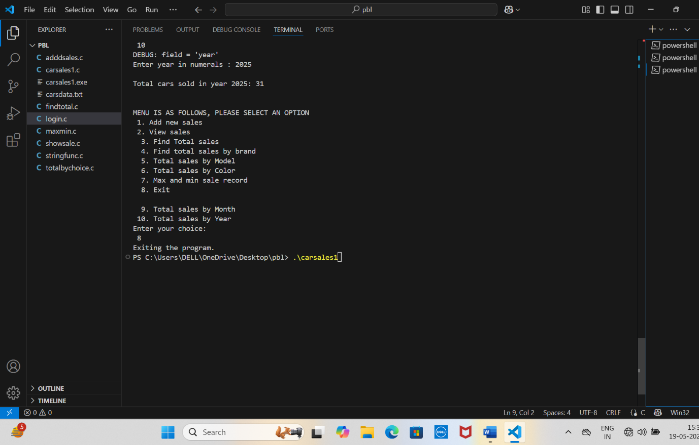

Output on entering choice 8- exit

**CONCLUSION AND FUTURE SCOPE**

The Car Sales Tracking System project shows us that a simple C program can be effectively used to solve real-world problems like tracking and managing sales data. By utilizing file handling and structures in the c programming, it automatically performs the tasks, which would otherwise be a manual and error-prone process. This system ensures great accuracy, faster data retrieval, and an overall smooth flow for car dealers or individual users.

There are exciting possibilities for enhancing this project. Integrating a graphical user interface (GUI) would significantly improve user experience, making the system more presentable and accessible. Moving from flat text files to a database system or creating a particular application for the same task could provide better data storage and facilities. Additional features such as search, filter, monthly reports, and cloud backup would shift the system to a more professional level.

With these improvements, the Car Sales Tracking System has the potential to evolve into a full-fledged sales management tool ready for the real-world usage.

**5. References**

1. Let Us C by Yashavant Kanetkar

2. C Programming Language by Kernighan & Ritchi

3. Tutorialspoint - File Handling in C

4. GeeksforGeeks - C File Handling

Websites such as :

1. Coding Ninjas (Blog & Courses

https://www.codingninjas.com/blog

1. CodeWithHarry

* 📌 <https://www.codewithharry.com/>